

**Ministry of Agriculture**

**Agricultural Marketing Section**

# MONTHLY MARKET BULLETIN

**August, 2024**

**Executive Summary**

Staple food prices increase and decrease in August and continue to remain at their lowest and highest levels compared to price last year and five -year average. Prices of sorghum and rice declined by 3.1%, 1.7% respectively, Price of maize, wheat and round potato increased by 3.2%,2.4% ,0.7% while price of dry beans remain unchanged. Price of maize is expected to ease as a result of improved supply from ongoing early-season harvesting in various production areas. Early harvesting of crops like rice and dry beans has improved supply of food crops. Food prices are expected to ease as the country is in harvesting season. Tanzania’s tradition export crops increase and decrease at different rates in August, 2024 Price of coffee arabica increased by 1.6% price of tobacco and cotton decreased by 18.7%, 1.6%, However price of tea and coffee robusta remain constant. import substitution commodities (edible oil and wheat) and farm inputs (fertilizer) increase and decrease at different rates, price of edible oil, urea fertilizer and DAP fertilizer increased by 4.0%,1.8% and 1.2% respectively while price of wheat decreased by 3.6 respectively.

1



## 1. Domestic Market Prices: Staple foods Table 1: Changes in market price of major staple foods (%)

|  |  |  |  |  |  |  |
| --- | --- | --- | --- | --- | --- | --- |
|  | **Maize** | **Rice** | **Beans** | **Potato** | **Sorghum** | **Wheat** |
| **Annual change (Aug 2023/24)** | **▼33.2%** | **▼21.2%** | **▼1.3%** | **▲22.1%** | **▲13.8%** | **▲16.0%** |
| **5 Year average** | **▼8.0%** | **▲4.6%** | **▲18.6%** | **▲28.6%** | **▲20.5%** | **▲20.5%** |
| **Monthly change (JulAug 2024)** | **▲3.2%** | **▼1.7%** | **►0.0%** | **▲0.7%** | **▼3.1%** | **▲2.4%** |

Prices for major staple food crops increased and decreased at different rates in August, annual and five--year average (Table 1). In August, decrease in price was observed in sorghum (3.1%) and rice (1.7%) while price of maize, wheat and round potatoes increase by 3.2%,2.4%,0.7% similarly beans remain unchanged.

## Maize



In August, the average wh~~o~~lesale price increased by 3.2 percent, from



TZS 62,900/100kg bag in July to TZS 64,900 in August (Table 1). Despite the August price increase, maize prices decrease by 33.2% and 8.0% lower than the previous year’s comparable month and the five-year August averages, respectively (Figure 1) Prices is expecting to ease as a result of improved supply from ongoing early-season harvesting in various production areas.

-

20,000

40,000

60,000

80,000

100,000

120,000

Aug-20

Aug-21

Aug-22

Aug-23

Aug-24

TZS/100kg bag

Figure 1: Average market price of maize during month of

Aug 2020

-

2024

Market price

5

year average

3

## Rice

Rice prices decreased by 1.7 percent in August, declining from TZS

200,100/100kg bag in July to TZS 196,700/100kg bag in August (Table 1). Similarly, prices decreased by 21.2% in August compared to the previous year's same month, and increased by 4.6% compared to the five-year August averages (Figure 2). Prices have begun to ease as a result of supply from ongoing early-season harvesting in various production areas.

-

50,000

100,000

150,000

200,000

250,000

300,000

Aug-20

Aug-21

Aug-22

Aug-23

Aug-24

TZS/100kg bag

Figure 2: Average market price of rice during month

of Aug 2020

-

2024

Market price

5

year average

**Dry beans**

Beans prices

remain

ed

unchanged

in

August

,

that is

T

ZS

258,100

/100

kg

bag

in

July

to

about

TZS 2

58,100

/100

kg

bag

in A

u

gust

.

Price trend shows

a decline in prices over

the past three months. This could be due to improved supply from

various

production areas. However

, prices in

August

remained

significantly

lower

by about

1.3

%

similar month

previous year and

higher than 18.6%

the five

-

year

August

average,

respectively (Figure 3).

**Sorghum**

The monthly average wholes

ale price of sorghum

decreased

by

3.1

percent

in

August

, from TZS 1

49,000

/100kg bag in

July

to TZS

1

44,400

/100kg bag in

August

. However,

prices rem

ained higher at

13.8

%

in

August

compared to the same mont

h the previous year, and were

20.5

%

higher than the five

-

year May

average.

(

Figure

4).

-

50,000

100,000

150,000

200,000

250,000

300,000

Aug-20

Aug-21

Aug-22

Aug-23

Aug-24

TZS/100kg bag

Figure 3: Average market price of dry beans during

month of Aug 2020

-

2024

Market price

year average

5

-

20,000

40,000

60,000

80,000

100,000

120,000

140,000

160,000

Aug-20

Aug-21

Aug-22

Aug-23

Aug-24

TZS/100kg bag

Figure 4: Average market price of sorghum during

month of Aug 2020

-

2024

Market price

5

year average

|  |  |
| --- | --- |
| **Round potatoes**  In August, round potato wholesale prices increased by 0.7 percent, from  TZS 105,500/100kg bag in July to TZS 106,200/100kg bag in August. 1 Similarly, prices remained 22.1% higher in the reporting period compared t to the same period the previous year, and 28.6% higher than the five- s year August average (Figure 5). a      -  20,000  40,000  60,000  80,000  100,000  120,000  Aug-20  Aug-21  Aug-22  Aug-23  Aug-24  TZS/100kg bag  Figure 5: Average market price of round potatoes  during month of Aug 2020  -  2024  Market price  5  year average | **Wheat**  Wheat grain wholesale prices increased by 2.4 percent in August, from TZS  85,700/100kg bag in July to TZS 190,200/100kg bag in August. Prices, on he other hand, were 16% higher in the reporting period compared to the ame period the previous year, and 20.5% higher than the five-year August verage (Figure 6). |
| Figure 6: Average market price of wheat during month of Aug 2020-2024  200,000  -  50,000  100,000  150,000  Aug-20  Aug-21  Aug-22  Aug-23  Aug-24  TZS/100kg bag  Market price  5  year average |
|  |

## 2. Global Prices: Traditional Export commodities (Source: World Bank, 2024)

## Coffee

In August 2024, coffee prices have changed at different rates compared to July. Arabica prices increased by 1.6 percent but remained higher than they were a year ago. After a drop in May,2024 Robusta prices have been increasing, in August price of coffee remain unchanged by 0.0 percent. (Figure 7). There remain significant risks to global coffee supply: while weather conditions in East Asia have improved, easing pressures on Robusta prices, recent concerns over Brazil’s Arabica production, arising from adverse weather in August (World Bank,2024)

## Tea

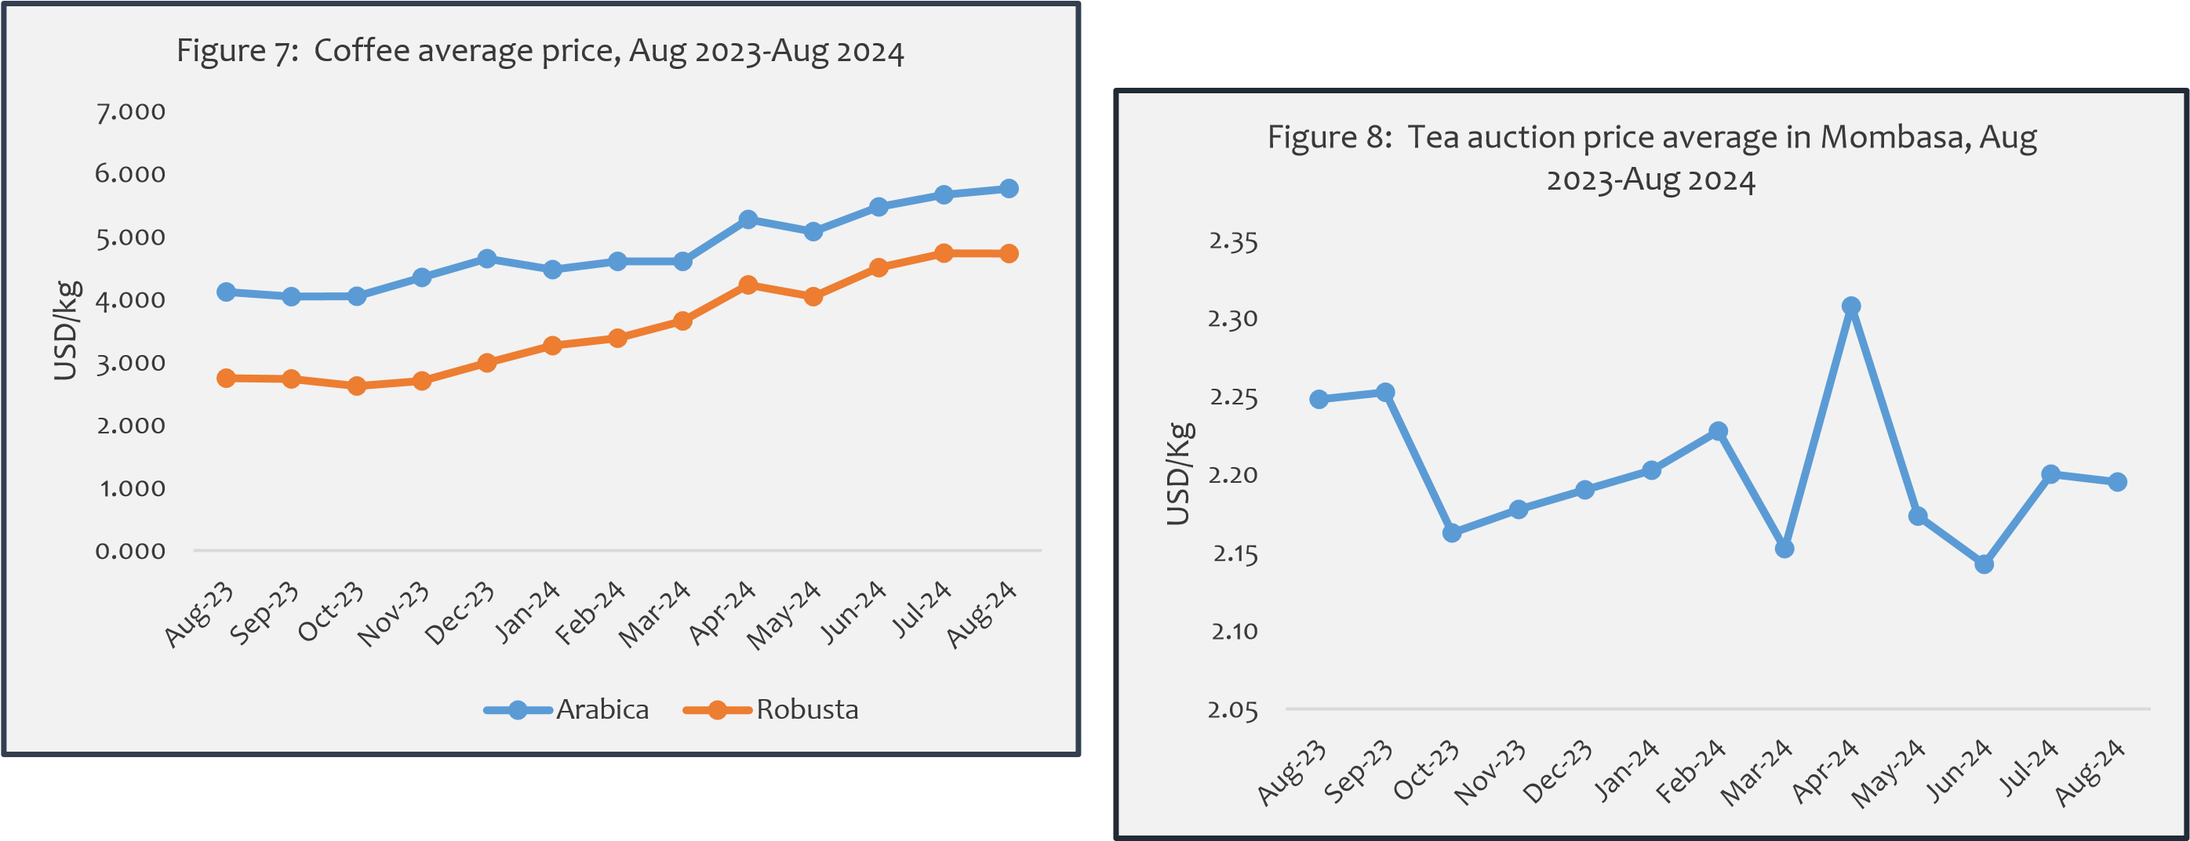Tea price remain unchanged from July to August 2024, international tea prices have started to decline from its peak 2.3 in April to 2.1 in June. Prices at the Mombasa auction market remain unchanged in August, compared to their prices in July, from USD 2.20/kg in July 2024 to USD 2.20/kg in August 2024 (Figure 8). The moderate rise in average tea prices reflects, in part, lower production from South Asian producers, including India, Bangladesh, and Sri Lanka. Meanwhile, in Kenya the world’s leading tea exporter— production increased by 25 percent over the same period due to improved weather conditions (World Bank,2024).

*Benchmark: Tea (Mombasa/Nairobi auctions), African origin, all tea*

## Cotton

|  |
| --- |
| **Tobacco**  Over the last year August,2023, global tobacco prices have been slightly increase. However, Prices picked up in March, 2024 to 5608.24USD/ton while on April started to decrease from 4661.32 to 4729.6 in June, and rise in July then it highly from 6015.53 USD/ton in July to 4889.62 USD/ton in August which is equivalent to  18.7% (Figure 10). |

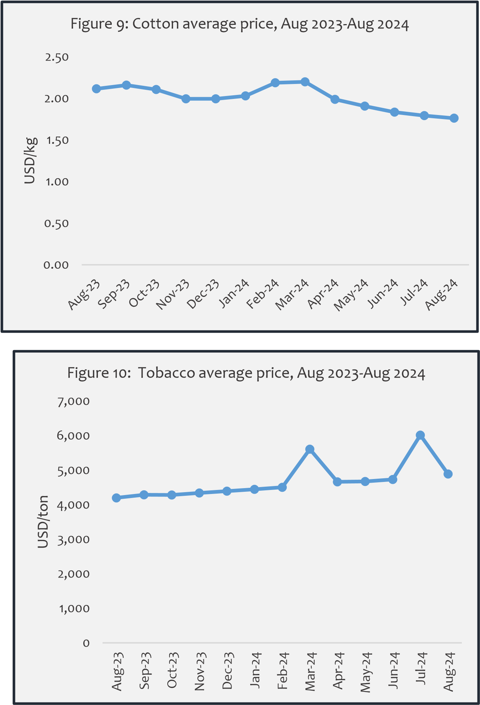Cotton prices have been increasing and decreasing over the last year but peaked at march 2024 to 2.2 USD/kg and then slight drop from 1.79 USD/kg in July to 1.76 USD/kg in August. Global consumption of cotton has weakened recently causing a decline in price, the recent decline is attributed to weakening demand and strong production prospects for the 2024/2025 crop season, which has just begun. (World Bank,2024)

## 3. Import Substitution Commodities (Source: World Bank, 2024)

### Wheat

Ukraine and Russia accounted for nearly 30% of global wheat exports. Following several months of Russia’s invasion of Ukraine, prices of wheat have soared. However, wheat observed a decline in prices from their pick in May 2024 reflecting improved supply prices (Figure 11). In August price of wheat (US HRW) decrease from 260.26 USD/ton in July to 250.85 USD/ton in August which is equivalent to 3.6%.

*\*Wheat (US), Hard Red Winter (HRW) and Soft Red Winter*

### Edible Oil (Palm)

The price of palm oil fell sharply from its peak in March 2024 to its lowest level in May 2024, then start to increase. Palm oil prices increased marginally by 4.0 percent in August 2024, from USD 896.09/ton in July 2024 to 932.63 /ton in August, 2024 (Figure 12). Tanzania imports a larger amount of edible oil. For the fiscal year ending July 2024, the import bill was USD mil 129.6 (BoT,2024).

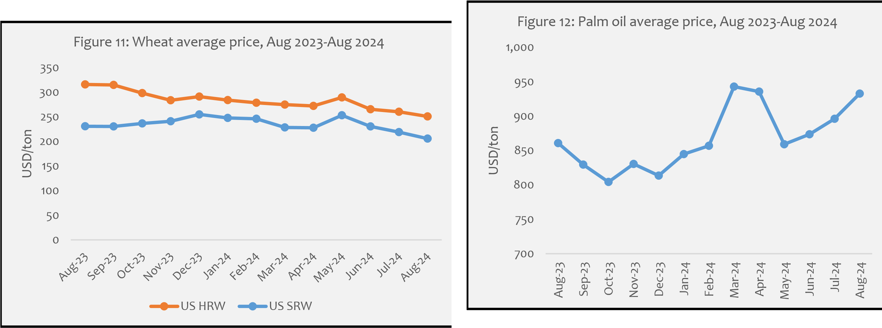

**4. Farm Inputs** (Source: World Bank, 2024)

### Fertilizer

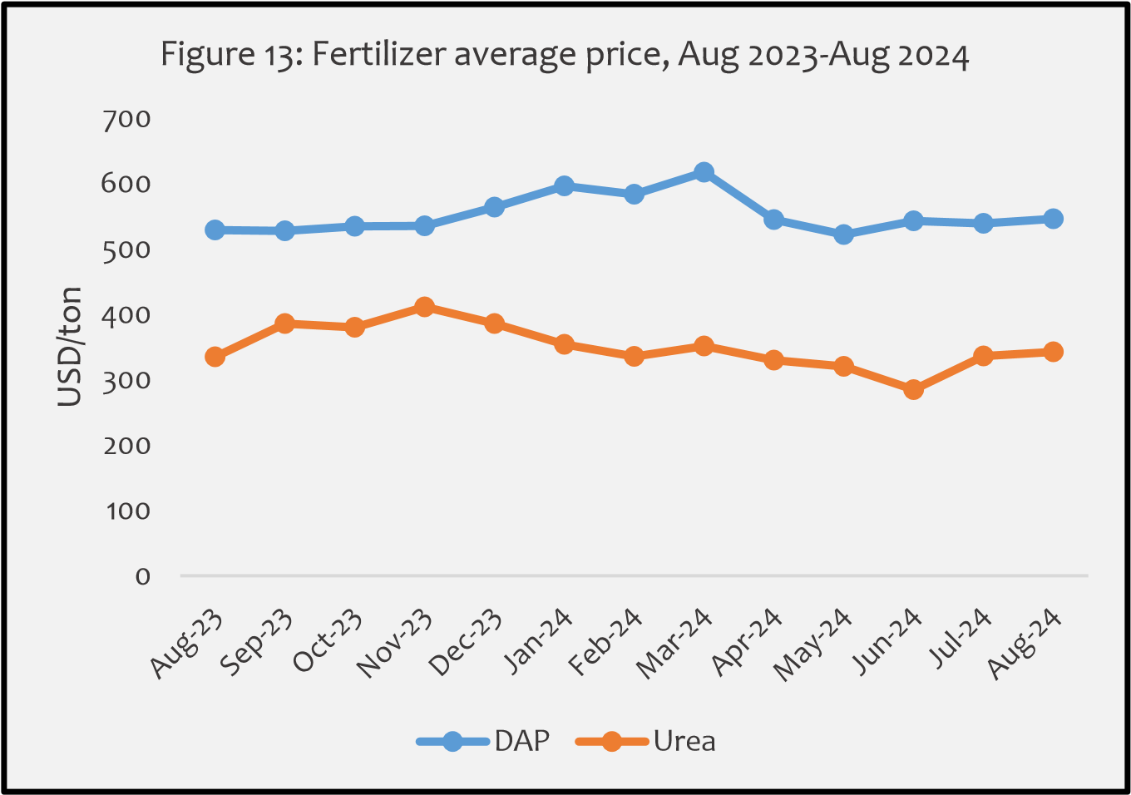 Urea fertilizers recorded decrease in price in June by 284.80 USD/ton but starting in July and August 2024 increased from 336.25 USD/ton to 342.50 USD/ton equivalent to 1.8% while DAP fertilizers increase from 539.40 USD/ton to 546.00 USD/ton equivalent to 1.2% (Figure 13). Tanzania imports roughly 90% of its fertilizer annual requirement. The fertilizer subsidy program, which is currently in effect, is expected to lower production costs and increase farm yield.

|  |
| --- |
| ***About the Bulletin***  This bulletin provides domestic and international markets outlook for five commodity groups including **staples** (maize, rice, beans, sorghum, and round potatoes), **traditional export crops** (coffee, cotton, tea, and tobacco), **import substitution commodities** (edible oil, and wheat) and **farm inputs** (fertilizer). This bulletin's information serves as a benchmark for key players along the respective value chains to make informed decisions.  **Disclaimer:** The views expressed in this bulletin are those of the authors and may not reflect those of the **Ministry of Agriculture (MoA)**. This bulletin is strictly for informational purposes only. The authors have made every effort to ensure accuracy of information provided; however, neither the Ministry of Agriculture nor the authors can guarantee such accuracy  **For further information, contact:**  ***Agricultural Marketing Section,*** ***P.O. Box 2182, DODOMA.***  ***Email:*** *masoko@kilimo.go.tz* |